Grasshoppers
Lindsey Reifel, Appleton-Whittell Research Ranch intern. Created January 2010

Grasshoppers can be found throughout the United States, are very important to the ecosystem, and provide a source of food for many animals. Birds such as the mockingbird and sparrows eat grasshoppers, as do many reptiles, and even some mammals such as the grasshopper mouse. They also can be a large influence on the lands that they inhabit, and sometimes can become costly pests to crops when large numbers of them invade one area.
When identifying grasshoppers there are some key features to look at to help determine which species it is. Some of these features include the color of the tibia (lower hind leg), shape of the head, color of both the tegmens (outer wings) and the flight wings (inner wings), stripes or speckle pattern, overall color, and size. There are four different size categories for grasshoppers: small (~11mm), average (~22mm), large (33mm), and robust (44⁺mm). Female grasshoppers tend to be larger then the males.
Grasshoppers go through several stages before reaching the adult form. These intermediate stages are known as instars. Instars look like little adult grasshoppers but not necessarily the adult form that they will become. There is on average 4-5 instar stages before reaching adulthood, color and body proportions can change during each one. It can be hard to distinguish if you are looking at an instar or an adult, and therefore can be confusing when indentifying. Only adults are described in the following section.
1”
25.4 mm
Grasshoppers of the Research Ranch

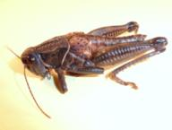
Plains Lubber (Brachystola magna)–The Plains Lubber is one of the largest grasshoppers in North America, and adults range in size from 43-55mm. It is found throughout the middle of North America from Montana down to mid Mexico. The Plains Lubber is found in a variety of prairie habitats including desert prairie, such as on the Research Ranch. (Photo by Lindsey Reifel)

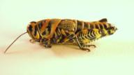
Rainbow Grasshopper (Dactylotum bicolor) - This colorful grasshopper is easily identified by the bright blue, yellow, and orange colors it displays across its body. It can range in size from 20-35mm. The Rainbow Grasshopper can be found in shortgrass prairie and desert prairie throughout the western United States from Southern Canada to Northern Mexico. (Photo by Lindsey Reifel)
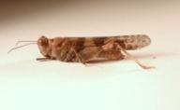
Pallidwinged Grasshopper (Trimerotropis pallidipennis)- Pallidwinged Grasshoppers can be found in the western half of the United States, and have been known to cause a great deal of damage to crops in Arizona. The tegmens (outer wings) have two dark bands, and the flight wings have a dark stripe running from edge to edge through the center of the wing which is a pale yellow color. These grasshoppers can range in size from 20.5-24mm for adult males and 27-33mm for adult females. (Photo by Lindsey Reifel)

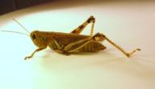
Differential Grasshopper (Melanoplus differentialis)- This grasshopper is found throughout a large portion of the United States. They can have devastating effects when found in large numbers around crops. This grasshopper is large and can be found ranging from 30-41mm. It is yellow-green in color, and has thick black marks on its legs. (Photo by Lindsey Reifel

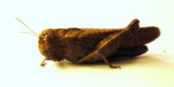
Speckledwinged Grasshopper (Arphia conspersa)- This grasshopper ranges in size from 20-21mm for adult males, and 30-37mm for adult females. The Speckledwinged Grasshopper has red flight wings that can be seen when they are flying. They have a very wide distribution and can be found from Alaska down through Mexico. (Photo by Lindsey Reifel)

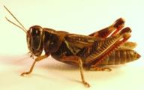
Redlegged Grasshopper (Melanoplus femurrubrum)- Redlegged Grasshoppers are a medium sized grasshopper that ranges in size from 17.5-28mm and can be found throughout the entire United States except at high elevations. They have bright red tibias, and a yellow colored underside. (Photo by Lindsey Reifel)

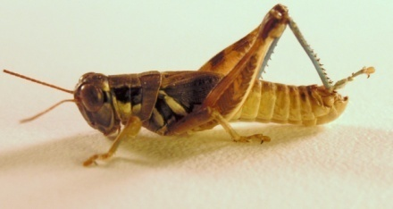
Lakin Grasshopper (Melanoplus lakinus)- This grasshopper is of medium size, ranging from 17.5- 22mm, and has blue tibias. Lakin Grasshoppers enjoy weedy rangeland and do not typically eat crops unless their preferred foods, plants from the goosefoot family, are hard to come by. (Photo by Lindsey Reifel)
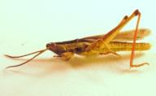
Twostriped Slantfaced Grasshopper (Mermiria bivittata)- The Twostriped Slantfaced Grasshopper can get rather large, ranging in size from 25-40mm, and has two distinct stripes down its body as the name suggests. They prefer tall grasses and can be found throughout a large portion of the United States that has prairie. (Photo by Lindsey Reifel)

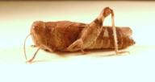
Blue-winged Grasshopper (Leprus wheeleri)- The Blue-winged Grasshopper has blue colored flight wings as the name implies. These are covered by the tegmen, outer flight wings, which are cream colored with tan spots. The rest of the body is a tan color that blends in with the Sonoran grasses very well. The Blue-winged Grasshopper can range in size from 35-57mm. (Photo by Lindsey Reifel)

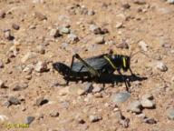
Horse Lubber (Taeniopoda eques)- The Horse Lubber has a very distinct color pattern. It has a mostly black body with bright yellow markings along its body and yellow veins in the wings. The Horse Lubber is much larger than most grasshoppers at 38-64mm. When the Horse Lubber is flying, bright pink can be seen under the dark tegmen. It has a range of Southwest United States down through Costa Rica. (Photo by Christine Hass)

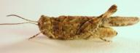
Mottled Sand Grasshopper (Spharagemon collare) - This relatively large grasshopper, ranging in size from 21-27.5mm, prefers habitats with sandy soil that is covered with little vegetation. The wings have a yellow disk that is bordered by a dark band that runs through the middle of the wing. (Photo by Lindsey Reifel)

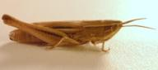
Obscure Grasshopper (Opeia obscura)- The obscure grasshopper can most readily be found on its favorite food source, blue grama, and has a range from southern Canada to central Mexico. It is very light in color with multiple stripes along the length of its body. It ranges in size from 13.5-15mm for adult males and 18-20mm for females. (Photo by Lindsey Reifel)

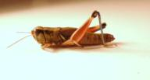
Largeheaded Grasshopper (Phoetaliotes nebrascensis)- Like the name suggests this grasshopper has a relatively large head compared to body size, which ranges from 17.8-19.4mm for adult males and 20.5-22.5mm for adult females. The Largeheaded Grasshopper prefers tall grasses, and has a range that extends from Michigan to California and from southern Canada to Northern Mexico. (Photo by Lindsey Reifel)

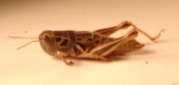
Humphrey’s Grasshopper (Barytettix humphreysii)- The Spur-throated Grasshopper is known for its large head with powerful mandible (lower jaw), and short wings that make it unable to fly. The Humphrey’s Grasshopper ranges in size from 19-36mm. This grasshopper can be found throughout Arizona, New Mexico, and Mexico. (Photo by Lindsey Reifel)

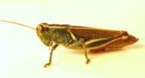
Two-striped Grasshopper (Melanoplus thomasi)- The Two-striped Grasshopper is a very bright colored grasshopper, and has two distinguishing stripes along its top. This grasshopper is only found in the southern part of Arizona, New Mexico, and Texas. The average size can range from 30-40mm. (Photo by Lindsey Reifel)

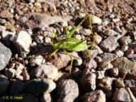
Short-winged Katydid (Dichopetala brevihastata) - The Short-winged Katydid can be found in the southern parts of Arizona, New Mexico, and Texas. It is a medium sized katydid, and can be found in brush, bushes, and grassy areas. It ranges in size from 13-25mm. (Photo by Christine Hass)

Here is a list of other grasshoppers that may be found on the Research Ranch. We currently do not have photos for these grasshoppers, but would love to use yours if you have any images of the following grasshoppers taken in the Elgin area please e-mail them to researchranch@audubon.org

- White-whiskered Grasshopper (Ageneotettix decorum)
- Striped Grasshopper (Amphitornus coloradus)
- Alkali Grasshopper (Anconia integra)
- Red-winged Grasshopper (Arphia pseudonietana)
- Creosote Bush Grasshopper (Bootettix argentatus)
- Meadow Grasshopper (Chorthippus curipennis)
- Hayden Grasshopper (Derotenema haydeni)
- Velvet-striped Grasshopper (Eritettix simplex)
- Snakeweek Grasshopper (Heserotettix viridis)
- Sagebrush Grasshopper (Inelanoplus bowditchi)
- Desert Clicker Grasshopper (Ligurotettix coquilletti)
- Yellow Spur-throat Grasshopper (Melanoplus yarrowii)
- Gladston Grasshopper (Melonoplus gladstoni)
- Many Hued Grasshopper (Poecilotettix sanguineus)
- Slant-faced Grasshopper (Psoloessa texana)
- Gray Bird Grasshopper (Schistoceca nitens)
- Leather-colored bird Grasshopper (Schistocera alutacea)
- Spotted Bird Grasshopper (Schistocerca lineate)
- Green Bird Grasshopper (Schistocerca Shoshone)
- Red-shanked Grasshopper (Xanthippus corallipes)
- Sumichrast’s Toothpick Grasshopper (Achurum sumichrasti)
- White-crossed Grasshopper (Aulocara femoratum)
- Boopedon Flaviventrus (Boopedon flaviventris)
- Crenulatewinged Grasshopper(Cordillacris crenulate)
- Lively Mermiria Grasshopper (Mermiria picta)
- Wyoming Toothpick Grasshopper (Parapomala wyomingensis)
- Montezuma’s Grasshopper (Syrbula montezuma)
- Arizona Spur-throat Grasshopper (Melanoplus arizonae)
- Red Whiskers Grasshopper (Melanoplus desultorius)
- Migratory Grasshopper (Melanoplus mexicanus)
- Regal Grasshopper (Melanoplus regalis)
- Panther-spotted Grasshopper (Poecilotettix pantherinus)
- Ridged Grasshopper (Conozoa carinata)
- Oak Leaf Grasshopper (Tomonotus ferruginosus)
- Broad-banded Grasshopper (Trimerotropis latifasciata)
- Toad Lubber (Phrynotettix tschivavensis)

Arnett, R.H., Jacques, R.L. 1981. Simon & Schuster’s Guide to Insects. Simon & Schuster Inc.
New York, NY.

Jepson, K. 1986. Key to the Grasshoppers (Orthoptera: Acrididae) of the Appleton-Whittell
Research Ranch, Santa Cruz County, Arizona.

Borror, D.J., White, R.E. 1970. Peterson Field Guides: Insects. Houghton Mifflin Company.
Boston, MA.

